CMPG 325 – COMPUTER NETWORKS
MILESTONE 1 – CLIENT DESIGN REVIEW
Iketsetseng Private School (Mahikeng)
Student | KHUMALO N
Student Number | 42606152
Project ID | CMPG325-2026-022
Client ID | CLI-022
Assigned Organisation | Iketsetseng Private School (Mahikeng)
Assigned Addressing Block | 192.168.21.0/24

1. Client Requirements
Iketsetseng Private School (Mahikeng) is the client for this project, operating in the education sector. As the client, the school has not prescribed a technical design — it has stated a set of operational needs, and the design in this document is the response to those needs.
The following requirements are drawn directly from the client's project brief, including the allocated addressing block 192.168.21.0/24, the client's wireless-security concern, and the client's change request for an additional floor or building area:
- The school needs both wired and wireless connectivity across its premises to support day-to-day operations.
- Requires allocated the IPv4 address block 192.168.21.0/24 and expects the network design to work within it.
- The school requires basic network services — including DHCP and DNS/local services — so that devices can obtain addresses and resolve names without manual configuration.
- The school has raised a specific security concern around wireless access and needs it secured using WPA2-PSK, with evidence that the configuration works.
- The school has submitted a change request asking for wireless coverage to be extended to an additional floor or building area not originally in scope.
- Needs devices across the network to be able to reach each other end-to-end, with testing to confirm this work.
- The school has flagged that Internet bandwidth is limited and costly and wants the design to avoid unnecessary reliance on it.
- The school expects a working, testable implementation in Cisco Packet Tracer, with evidence showing the building documented in GitHub.

2. Physical Topology
The proposed physical topology uses an edge router connected to a main access switch. The switch connects the school server, wired computers, network printer and two wireless access points. AP-1 serves the main floor, while AP-2 provides wireless coverage for the additional floor required by the change request.

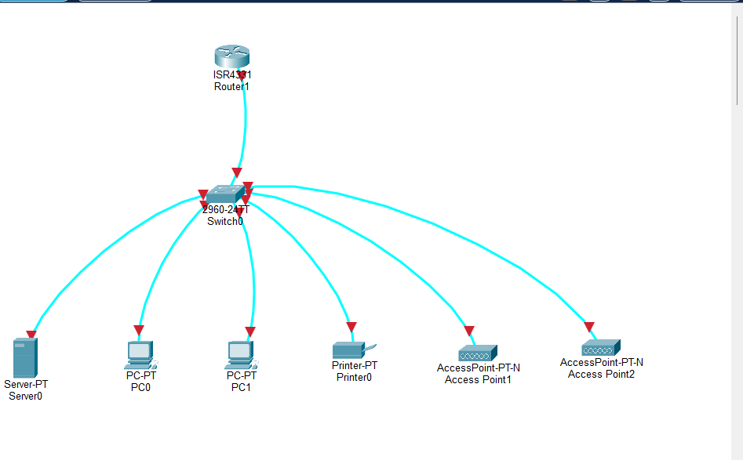

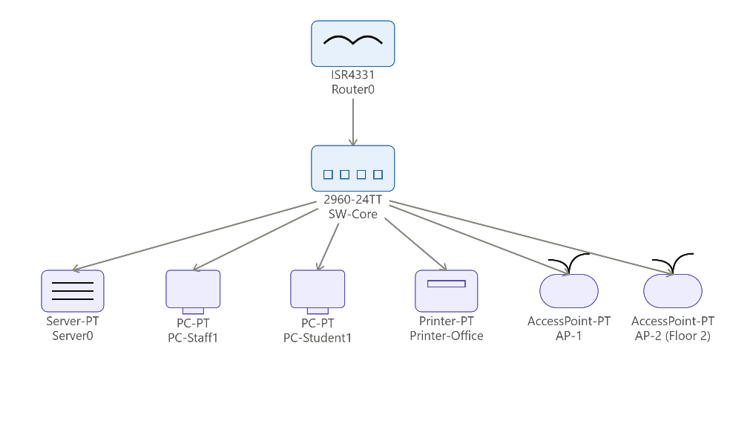

3. Logical Topology
The logical design separates major categories of traffic into VLANs and subnets. This supports better control of broadcast traffic, easier management and future expansion while keeping the design within the assigned /24 address block. The wireless network is logically isolated into its own VLAN and is protected using WPA2-PSK.
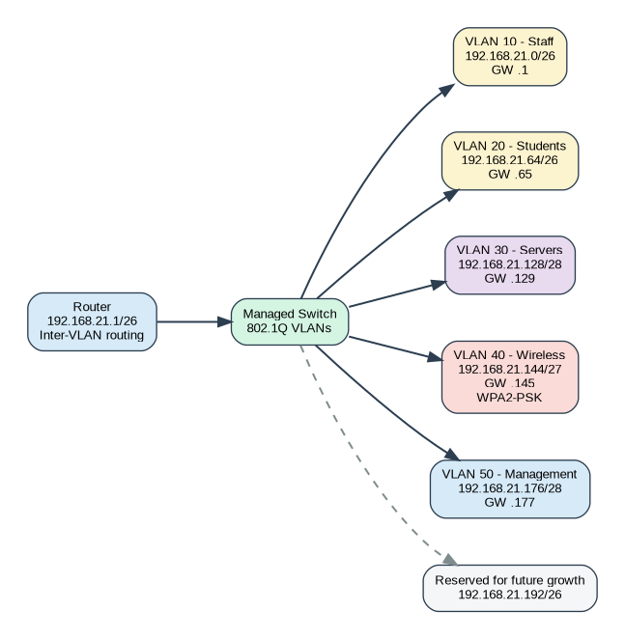

4. IP Addressing Plan
This is the initial subnetting plan for the allocated 192.168.21.0/24 block. Variable-length subnetting is used so that larger groups receive more usable addresses while smaller infrastructure networks do not consume unnecessary address space.

VLAN | Purpose | Network | Prefix | Usable Host Range | Gateway | Notes
10 | Staff | 192.168.21.0 | /26 | 192.168.21.1 – 192.168.21.62 | 192.168.21.1 | Up to 62 hosts
20 | Students / Labs | 192.168.21.64 | /26 | 192.168.21.65 – 192.168.21.126 | 192.168.21.65 | Up to 62 hosts
30 | Servers | 192.168.21.128 | /28 | 192.168.21.129 – 192.168.21.142 | 192.168.21.129 | Up to 14 hosts
— | Spare / Reserved | 192.168.21.144 | /28 | 192.168.21.145 – 192.168.21.158 | — | Reserved, unused (alignment gap)
40 | Wireless | 192.168.21.160 | /27 | 192.168.21.161 – 192.168.21.190 | 192.168.21.161 | Up to 30 hosts; WPA2-PSK
50 | Network Management | 192.168.21.192 | /28 | 192.168.21.193 – 192.168.21.206 | 192.168.21.193 | Up to 14 hosts
— | Future Growth | 192.168.21.208 | /28 | 192.168.21.209 – 192.168.21.222 | — | Reserved for expansion

Initial Device Addressing
- Router LAN/sub interfaces: use the first usable address in each VLAN as the default gateway.
- Server: assign a static address within the Server VLAN, for example 192.168.21.130/28.
- AP-1: assign a static management address in the Management VLAN, for example 192.168.21.193/28.
- AP-2: assign a static management address in the Management VLAN, for example 192.168.21.194/28.
- End-user PCs and wireless clients: use DHCP from the appropriate address pool.

The Wireless VLAN was moved from an originally proposed 192.168.21.144/27 to 192.168.21.160/27, since /27 blocks must start on a 32-address boundary and .144 is not a valid one. This created a 16-address spare block at 192.168.21.144/28, which is reserved alongside the existing future-growth range at 192.168.21.208/28.

Design Decisions and Rationale

- A separate wireless VLAN is proposed so wireless traffic can be managed independently, and the WPA2-PSK security requirement is clearly demonstrated.
- A second access point is included specifically to satisfy the client change request for coverage on the additional floor/area.
- A local server is proposed for DHCP/DNS and other local services so routine local traffic does not depend unnecessarily on the Internet, helping to respect the limited and expensive bandwidth constraint.
- Two smaller reserved blocks — 192.168.21.144/28 and 192.168.21.208/28 — are set aside for future growth, so additional devices or network segments can be accommodated without redesigning the address plan.

